|  |  |
| --- | --- |
|  | Faculty of Information Science and Technology  Universiti Kebangsaan Malaysia  43600 Bangi Selangor |
| **TTTK2103**  **Computer Network Technology** | |

**PACKET TRACER**

1.0.5 Logical and Physical Mode Exploration

1.5.5 Network Representation

|  |  |
| --- | --- |
| **Name** | **Matrix Number** |
| Mariam binti Masuan | A182976 |
| Mohamad Saiful Nizam bin Abd Aziz | A179830 |

1.0.5 Logical and Physical Mode Exploration

**Part 1: Investigate the Bottom Toolbar**

* What are the subcategories for Network Devices?

Answer: Routers, Switches, Hubs, Wireless Devices, Security, WAN Emulation.

**Part 2: Investigate Devices in a Wiring Closet**

* What devices use a wired connection to connect to switch ALS2?

Answer: ALS1, Access_Point, WebServer.

* Which device is connected to Access_Point?

Answer: Laptop_1

* Where is the device connected to Access_Point physically located?

Answer: On the Table

**Part 3: Connect End Devices to Networking Devices**

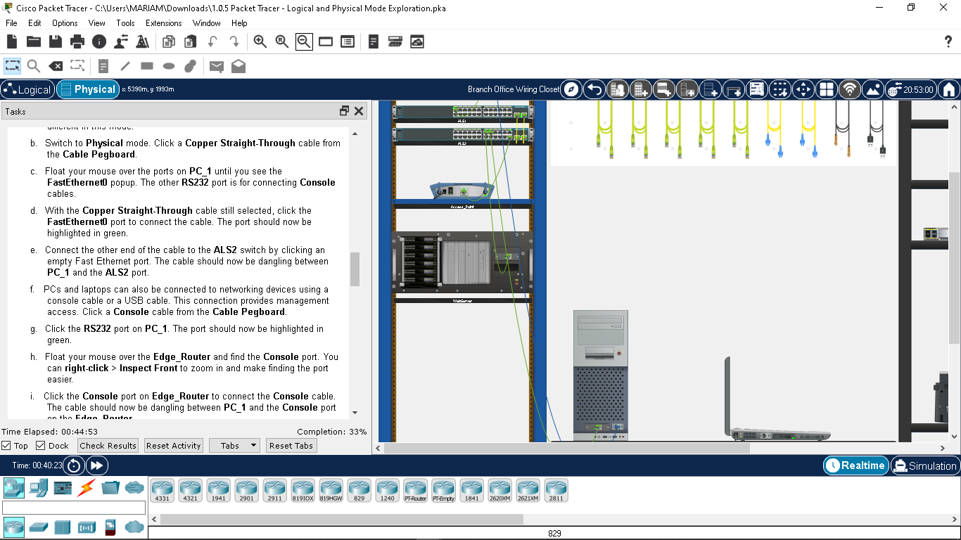Wire 1 (green):

**1**

**2**

-Source Device: PC_1

-Source Port: FastEthernet0

-Dest. Device: ALS2

-Desr. Port: FastEthernet 0/15

-Cable Type: Copper Stright-Through

Wire 2 (blue):

-Source Device: PC_1

-Source Port: RS 232

-Dest. Device: Edge Router

-Desr. Port: Console

-Cable Type: Copper Roll-Over

**Part 4: Install a Backup Router**

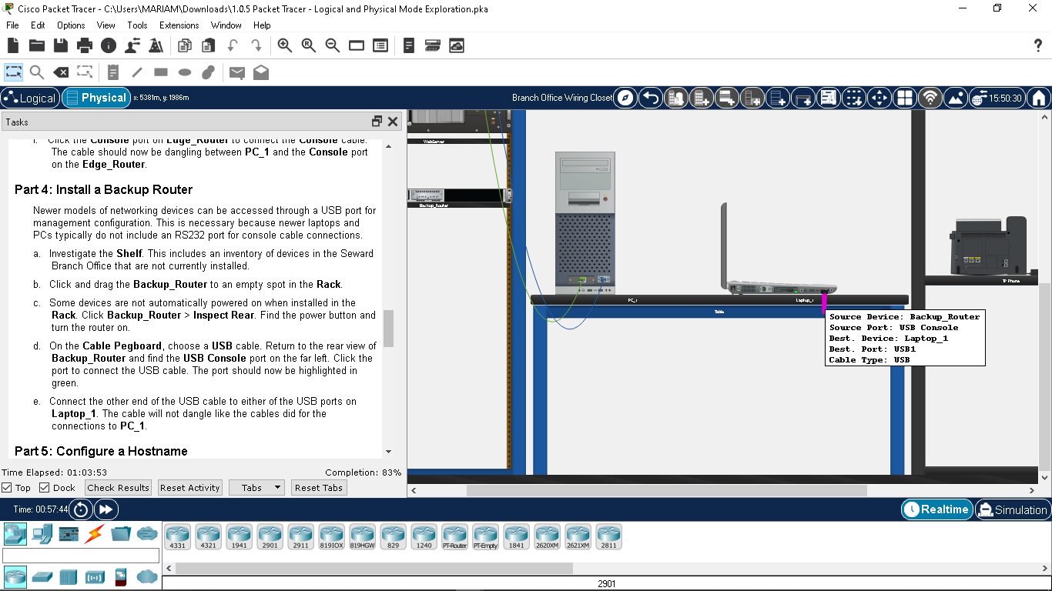

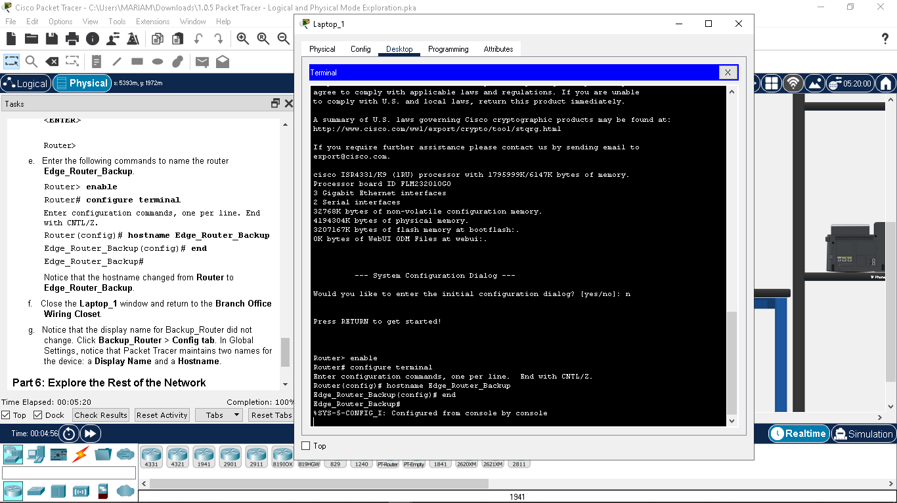**Part 5: Configure a Hostname:**

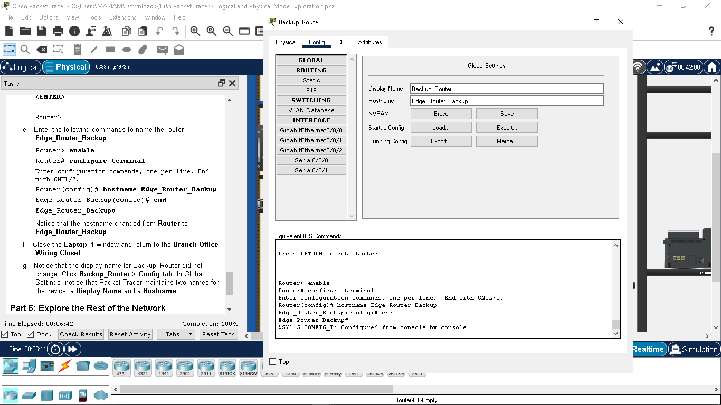

**Part 6: Explore the Rest of the Network**

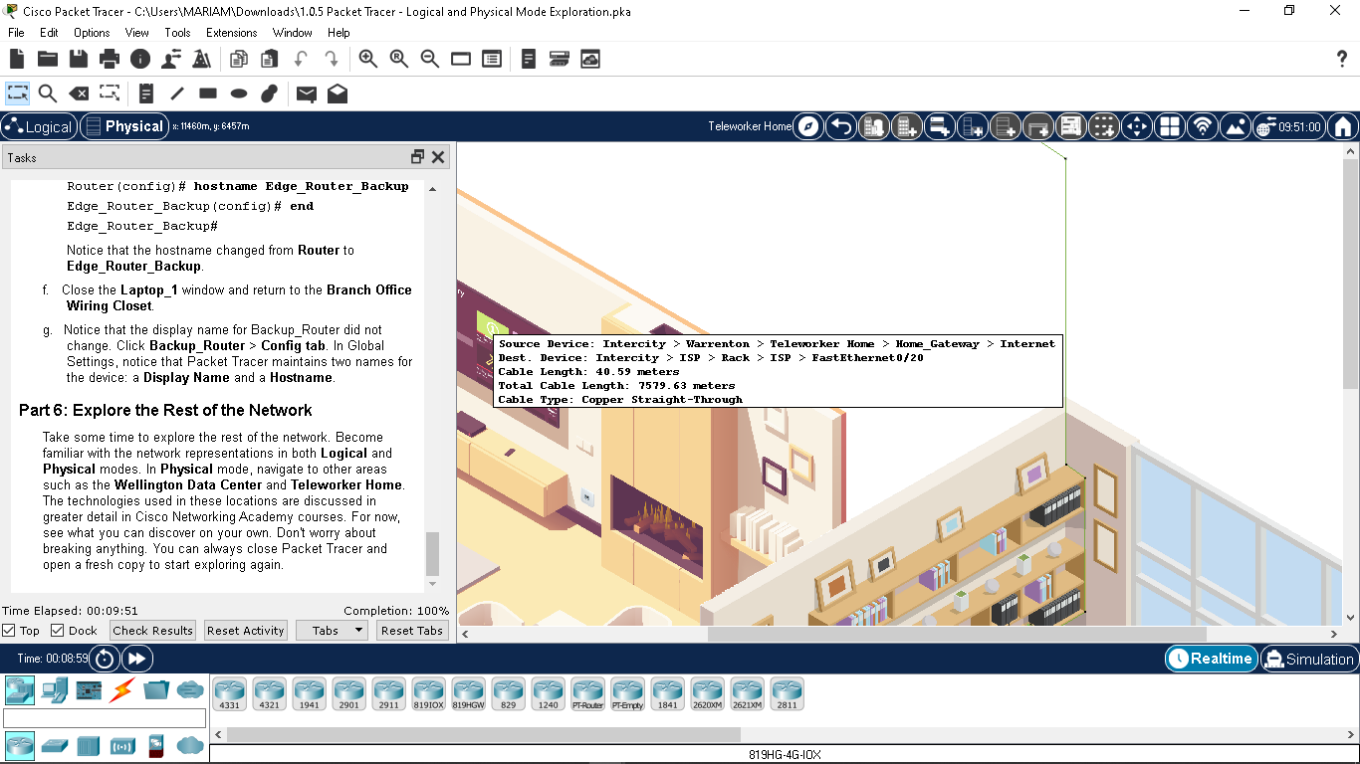

1.5.5 Network Representation

**Part 1: Identify common component of a network as represented in Packet Tracer**

* List the intermediary device category

Answer: Wireless Router, Multilayer Switch, LAN switch, Firewall Appliance, Router

Without entering into the Internet cloud or Intranet cloud, how many icons in the topology represent

endpoint devices (only one connection leading to them)? 15 icons in the topology represent endpoint devices only

one connection leading to them

Without entering into the Internet cloud or Intranet cloud, how many icons in the topology represent

endpoint devices (only one connection leading to them)? 15 icons in the topology represent endpoint devices only

one connection leading to them

Without entering into the Internet cloud or Intranet cloud, how many icons in the topology represent

endpoint devices (only one connection leading to them)? 15 icons in the topology represent endpoint devices only

one connection leading to them

* Without entering into the Internet cloud or Intranet cloud, how many icons in the topology represent endpoint devices (only one connection leading to them)?

Answer: There are 15 icons in the topology that represent endpoint devices.

Without counting the two clouds, how many icons in the topology represent intermediary devices (multiple

connections leading to them)? 11 icons in the topology represent intermediary devices

* Without counting the two clouds, how many icons in the topology represent intermediary devices (multipleconnections leading to them)?

Answer: There are 11 icons in the topology that represent intermediary devices.

* How many end devices are not desktop computers?

Answer: There are 8 end devices that are not desktop computer.

How many different types of media connections are used in this network topology? 3 different types of

media connections are used in this network topology.

* How many different types of media connections are used in this network topology?

Answer: There are 3 different types of media connections that are used in this network topology.

**Part 2: Explain the purpose of the devices.**

* **In Packet Tracer, only the Server-PT device can act as a server. Desktop or Laptop PCs cannot act as a server. Based on your studies so far, explain the client-server model.**

Answer: Laptops and desktops are labeled as clients they only request information, from dedicated computers called servers which are designed to handle information request from clients.

* **List at least two functions of intermediary devices.**

Answer:Regenerate and retransmit communication signals, notify other devices of errors and communication failures, classify and direct messages according to priorities.

* **List at least two criteria for choosing a network media type.**

Answer: What is the maximum distance that the media can successfully carry a signal?; What is the cost of the media and installation?

**Part 3: Compare and contrast LANs and WANs.**

* **Explain the difference between a LAN and a WAN. Give examples of each.**

Answer: A LAN is a network infrastructure that spans a small geographical area such as a home, school, office building, or campus. A WAN is a network infrastructure that spans a wide geographical area such as between cities, states, provinces, countries, or continents

* **In the Packet Tracer network, how many WANs do you see?**

Answer: There are 2 WANs.

* **How many LANs do you see?**

Answer: There are 3 LANs.

* **The Internet in this Packet Tracer network is overly simplified and does not represent the structure and form of the real Internet. Briefly describe the Internet.**

Answer: The internet is a worldwide collection of interconnected networks (internetworks, or internet for short).

* **What are some of the common ways a home user connects to** **the Internet?**

Answer: Cable, DSL, cellular, satellite, dial-up telephone.

* **What are some common methods that businesses use to connect to the Internet in your area?**

Answer: Dedicated leased line, Metro-E, DSL, Cable, Satellite.

**Challenge Questions**

* 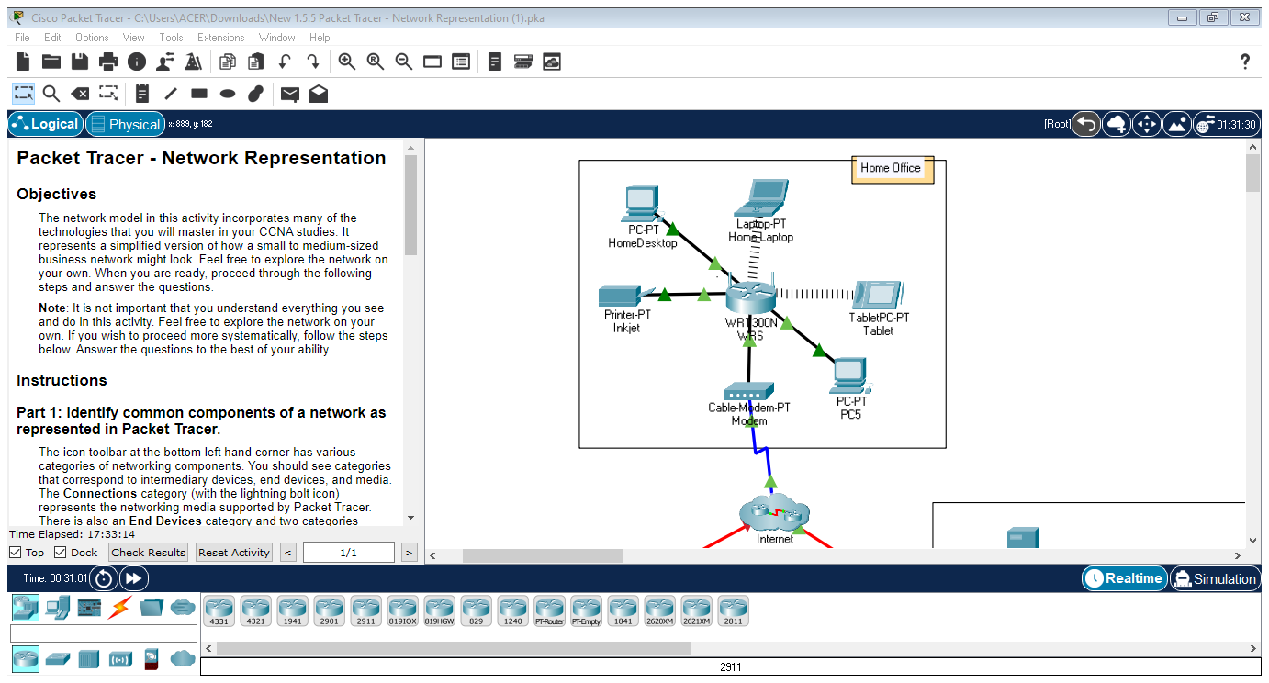**Add an end device to the topology and connect it to one of the LANs with a media connection. What else does this device need to send data to other end users? Can you provide the information? Is there a way to verify that you correctly connected the device?**

Answer: From above diagram, PC-PT PC5 has been connected to WR1300N WRS by using Copper Straight Through cable. Other than an intermediary device and cables, an end device also needs address to send data to other end users. The green arrows verify that the device is correctly connected, if it is not, the arrow will be red in colour.

* **Add a new intermediary device to one of the networks and connect it to one of the LANs or WANs with a media connection. What else does this device need to serve as an intermediary to other devices in the network?**

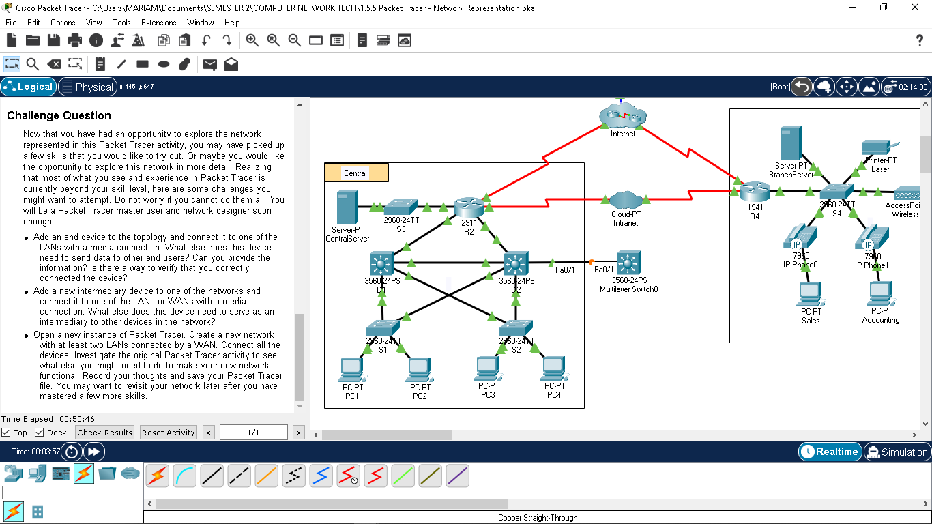



Answer: From above diagram, 3560-24PS Multilayer Switch0 has been connected to 3560-24PS D2 by using Copper Straight Through cable. Intermediary devices use the destination end device address, in conjunction with information about the network interconnections, to determine the path that messages should take through the network

* **Open a new instance of Packet Tracer. Create a new network with at least two LANs connected by a WAN. Connect all the devices. Investigate the original Packet Tracer activity to see what else you might need to do to make your new network functional. Record your thoughts and save your Packet Tracer file. You may want to revisit your network later after you have mastered a few more skills.**

